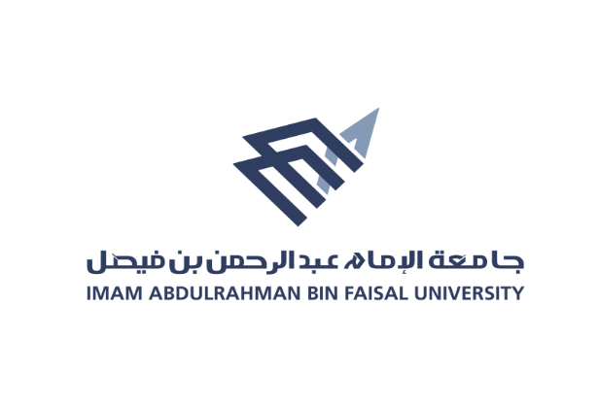
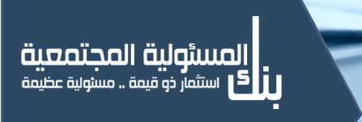
كليــــــــة التــمــــريض
College of Nursing

Annual Report 2018 - 2019

- Saudi National Day
The Saudi National Day was activated in Al-Amal Complex, Rehabilitation Department, on the date 19 / 9 / 2018, the number of participating students was 12 students, the number of beneficiaries was 30 persons, and it was led by several faculty members: Mrs.Zahraa Al-Maabar

- Mental Health Day
This day was activated in Al-Amal Complex, Rehabilitation Department, on the date 10/10/2018, the number of participating students was a 12 students, the number of beneficiaries was 30 persons, and it was led by a number of faculty members: Mrs. Zahraa Al-Maabar

- Breast cancer
This day was activated in college of Nursing, on the date 23/10/2018, the number of participating students was 39 students, the number of beneficiaries was 300 persons, and it was led by a number of faculty members: Mrs.Zahraa Al-Maabar, Mrs.Sahar Alghareeb

- First aid and Bls
This day was activated in The eighth secondary school in the golden belt, on the date 24 /10/2018, and the number of participating students was a 15 students, the number of beneficiaries was 30 persons, and it was led by a number of faculty members: Mrs.Seham Alreshidi, Dr.Hend Shenawai

- Obesity prevention
This day was activated in The Dhahran Private Schools, on the date 24 /10/2018, and the number of participating students was a 35 students, the number of beneficiaries was 200 persons, and it was led by a number of faculty members, Dr.Sama Hammad , Mrs.Sahar Alghareeb, Mrs.Areej AlOtaibai, Mrs. Ibtihal Almomen , Mrs.Hajar Alyahya , Mrs.Rawan Alghamdi.

- Antibiotic campaign
This day was activated in college of Nursing, on the date 20/11/2018, and the number of participating students was a 15 students, the number of beneficiaries was 70 persons, and it was led by a number of faculty members, Dr.Hend Shenawi , Dr.Sahar Alghareeb

- Diabetes Day
The diabetes day was activated in Prince Saud bin Nayef Park , on the date 22 / 11 / 2018, and the number of participating students was 35 students, the number of beneficiaries was 200 persons , and it was led by a number of faculty members: Dr.Naemah Fuad

- Management and leadership lectures
This day was activated in alfaisalyah school, on the date 25/11/2018, and the number of participating students was a 15 students, the number of beneficiaries was 40 persons, and it was led by a number of faculty members: Dr.Reem aldossary, Dr.Sherien , Dr.Amnah Omar

- Health food programmer
This day was activated in altarbyah school, on the date 25/11/2018, and the number of participating students was a 11 students, the number of beneficiaries was 200 child, and it was led by a number of faculty members: Mrs.Rawan Alghamdi, Ms.Khulood alyami, Ms.Aliah Aldossary, Mrs.Bushra Bawazair , Ms.Ohoud Aljaloud, Mrs.Norah Alnassar , Mrs.Rayanh Alghamdi

- Mobile clinic
This day was activated in Imam Abdualrhman bin Faisal University, college of sciences, on the date 27/11/2018, and the number of participating students was a 88 students, the number of beneficiaries was 180 persons, and it was led by a number of faculty members: Dr.Hend Shenawai , Dr.Sahar Metwally

- Mental health exhibition
This day was activated in King Fahad university, on the date 29/11/2018, and the number of participating students was a 80 students, the number of beneficiaries was 200 persons, and it was led by a number of faculty members: Dr.Naemah Fuad, Ms.Fatimah alqhatani

