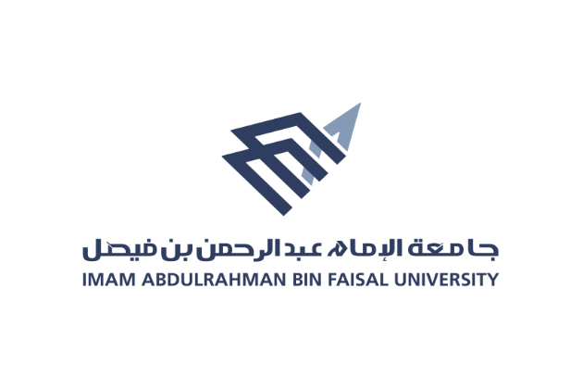
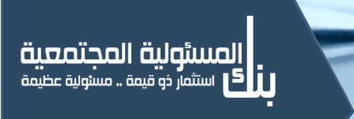
كليــــــــة التــمــــريض
College of Nursing

Annual Report 2019 - 2020

- World First Aid and Pulmonary Resuscitation Day
This day was activated in Weam Association, on the date 26 / 9 / 2019, and the number of participating students was 12 students, the number of beneficiaries was 30 persons, and it was led by several faculty members: Dr.Hind Al-Shennawy, Ms. Maram Al-Wadaei

- World Mental Health Day
This day was activated in - King Fahd University Hospital, Hope and Mental Health Complex, on the date 13/10/2019, and the number of participating students was 15 students, the number of beneficiaries was 50 persons, and it was led by a few faculty members from Psychological and mental health course

- World Breast Cancer Day
This day was activated in the fourth high school in Al-Khobar, on the date 15/10/2019, and the number of participating students was 10 students, the number of beneficiaries was 100 persons, and it was led by a few faculty members: Dr. Sahar Metwally, Mrs. Hanan Buqarin, Mrs. Zainab Al-Saba

- World Osteoporosis Day
This day was activated in Private education schools in Khobar, on the date 15/10/2019, and the number of participating students was 11 students, the number of beneficiaries was 150 persons, and it was led by a few faculty members: Mrs. Rayana Al-Ghamdi, Mrs. Noura Al-Nassar

- Global Handwashing Day
This day was activated in The fourth high school in Al-Khobar, on the date 22 /10/2019, and the number of participating students was a 15 students, the number of beneficiaries was 60 persons, and it was led by a number of faculty members: Dr. Wafaa El-Desouki

- World Breast Cancer Day
This day was activated in Al-Forsan International Schools (Intermediate/Girls), on the date 28 /10/2019, and the number of participating students was 10 students, the number of beneficiaries was 100 persons, and it was led by a number of faculty members: Dr. Sahar Metwally, Mrs. Nora Al-Otaibi, Mrs. Kholoud Al-Rashidi

- Global Handwashing Day
This day was activated in the third intermediate school in Dammam, on the date 29/11/2019, and the number of participating students was a 7 students, the number of beneficiaries was 50 persons, and it was led by a number of faculty members: Dr.Wafaa El-Desouki

- World Diabetes Day
The diabetes day was activated in the third intermediate school in Dammam, on the date 17 / 11 / 2019, and the number of participating students was 12 students, the number of beneficiaries was 80 persons, and it was led by a number of faculty members: Dr. Wafaa El-Desouki, Ms. Nora Al-Otaibi

- Psychological support and education for mothers of children with special needs:
sexual harassment
This day was activated in Derayah Center in Al-Khobar, on the date 2/12/2019, and the number of participating students was 20 students, the number of beneficiaries was 100 persons, and it was led by a number of faculty members: Dr. Wafaa El-Desouki

- How to deal with children with special needs
This day was activated in Gulf Girl Center, on the date 2/12/2019, and the number of participating students was 10 students, the number of beneficiaries was 100 persons, and it was led by a number of faculty members: Dr. Wafaa El-Desouki,

- Corona prevention
This day was activated in Private education schools on the date 25/2/2019, and the number of participating students was 5 students, the number of beneficiaries was 60 persons, and it was led by a number of faculty members: Mrs. Rayana Al-Ghamdi
Ms. Maram Al-Wadaei
Mrs. Sarah Abdel-Hay
Mrs.Hind Al-Otaibi

